Stores 2024 : changes

Stores 2023 : changes

Stores 2022 : changes

Stores 2021 : changes

STORES 2024

- Compatibility Windows 11
Stores has been adapted to run and work on Windows 11
together with the used databases SQL Server and MS Access

- Euro Sign :
Euro sign has been implemented on more labels
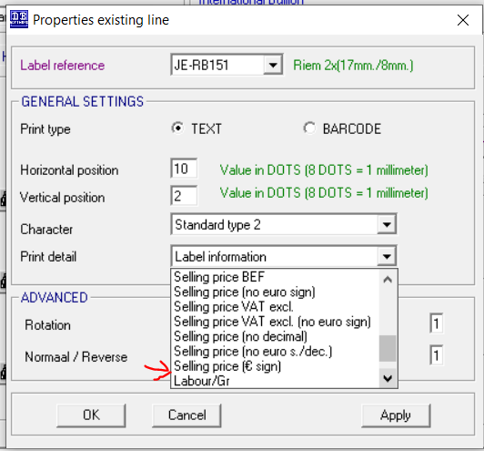

- Adjustment/corrections article(s) and stock adaption

Each stock adjustment can be registered in Stores
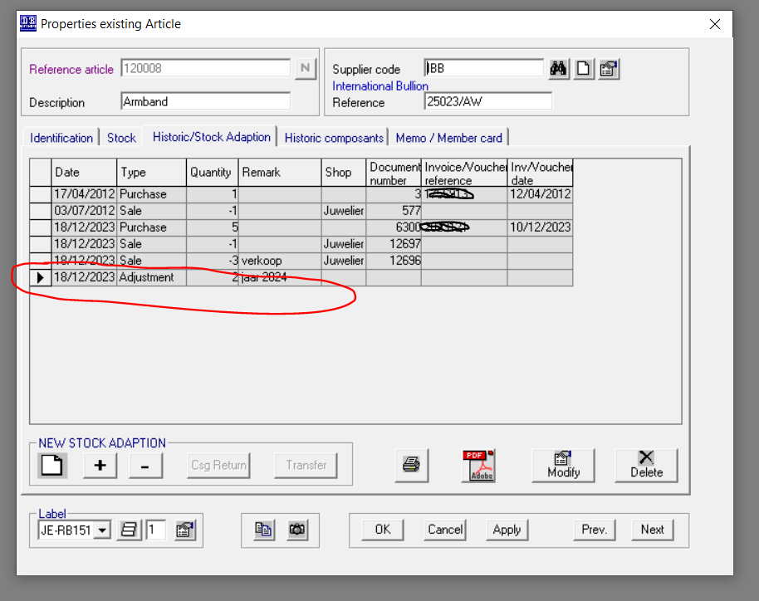

and these adjustments /corrections are now listed in a report
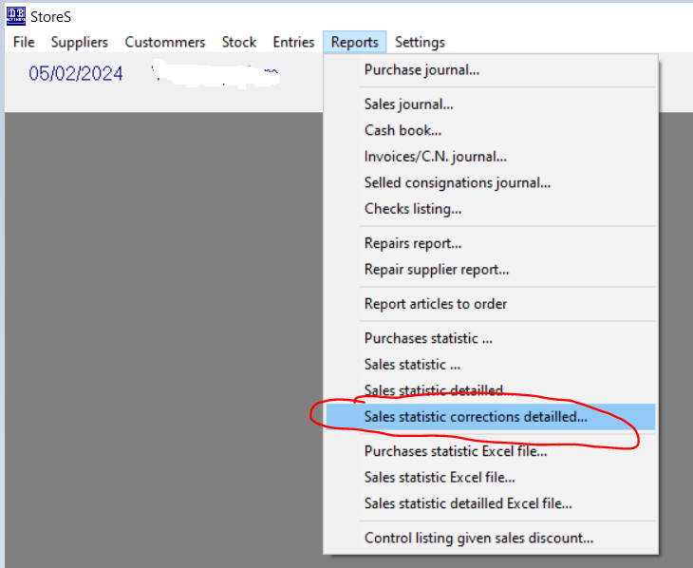

STORES 2023

- Repairs : barcode and username
- Suppliers : bankaccount as IBAN
- Report : repairnumber on sales journal
- Report : purchase date added on excel inventory report
- € sign on labels

- Repairs : barcode and username

When creating a new or changing an existing repairment, the username (or seller) can be
registered

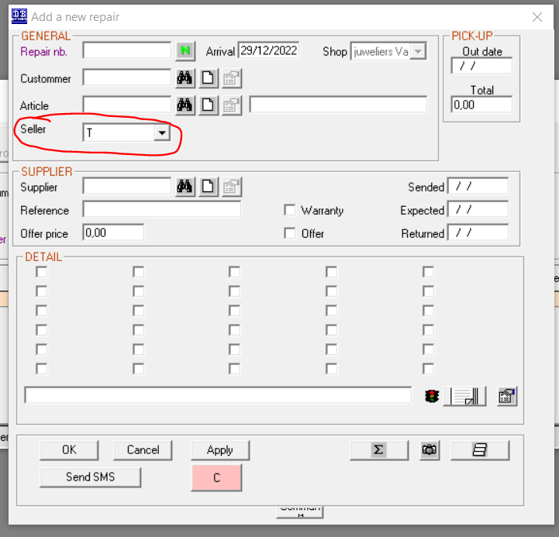

The username ( or seller ) will also be printed on the repair ticket.

- Suppliers : bankaccount as IBAN
The bank account of the supplier can be added in the format
of an IBAN number
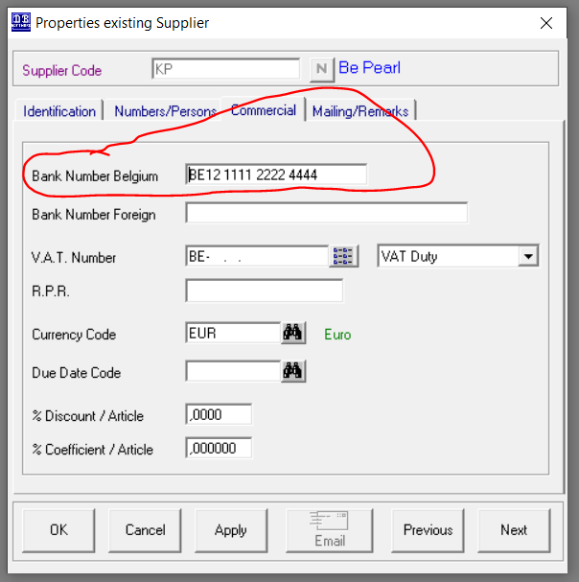

- Report : repairnumber on sales journal

The repairnumber will be printed on the sales journal.
This will make the report more readable on repair items.

- Report : purchase date added on excel inventory report
The Excel inventory document had been enlarged with a column. This column is the purchase date of the article. This was needed on request of a customer who had a burglary and needed this column for the court of law.

- € sign on labels
The € sign was missing on labels. With this version the € sign is printed on the labels.

STORES 2022

- Sales : print labelname on receipt
- Reports : Sales Statiscs detailed
- Repairs
- Print logo on invoice
- 4 lines text possible at the bottom of a receipt + barcode
- User ADM or MGR security
- New payment methods
- Display “number of articles in stock” on Articles overview screen
- Make a product Certificate

- Sales : print labelname on receipt

By default the receipt prints the article description on the receipt.
When selecting the chekbox “print labelname on ticket”, the “labelname” of the article
will be printed on the receipt and no longer the description.

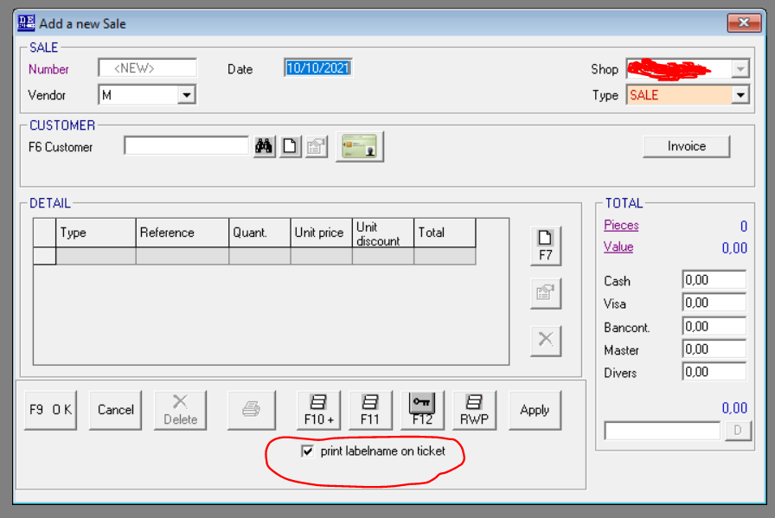

- Report : Sales Statistic detailed

This report displays the article reference, supplier, …
When selecting the checkbox “print decription” , the description of the article is add to the report. By default article description is not printed.

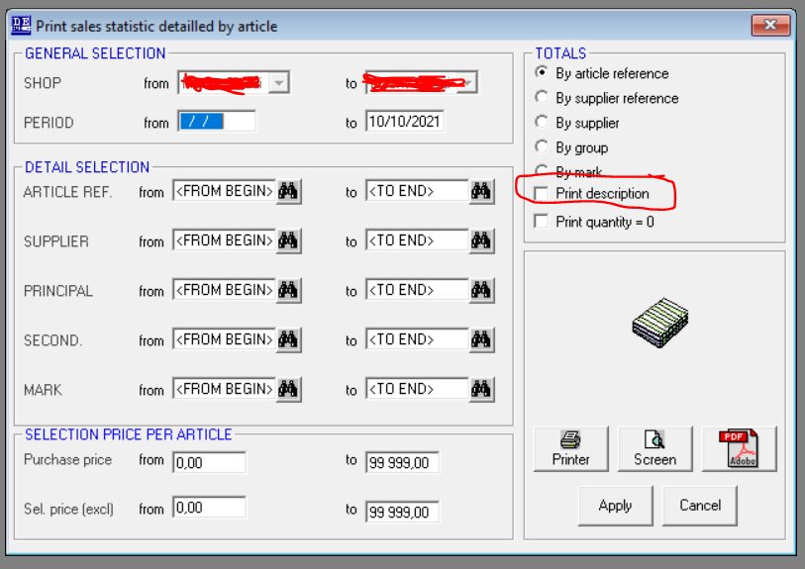

- Repairs

Reference number of the reparation is automatically endodes in the comments field at creation of
a new reparation.

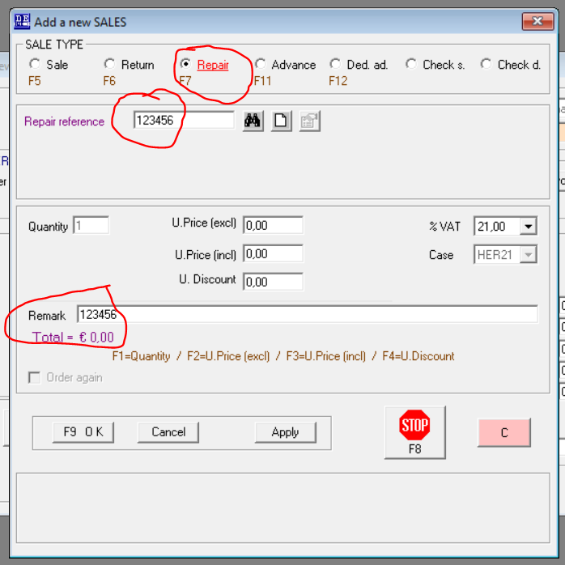

- Print logo on invoice

It is possible to print a logo of your store on the invoice(s)
Logo requirements
- Must be a .jpg file
- Width = 350 pixels
- Height = 150 pixels
- Resolution = 120 dpi
Put the logo in the map c:\StoresDATA
and filename must be logo.jpg

- Additional Lines at the bottom of a receipt + barcode
- Additional lines at bottom
4 lines standard text are possible at the bottom of a receipt
These lines will always be printed at each receipt if not empty.

Where to find these lines to fill in.
You can find these lines via the Menu – Settings - Shops

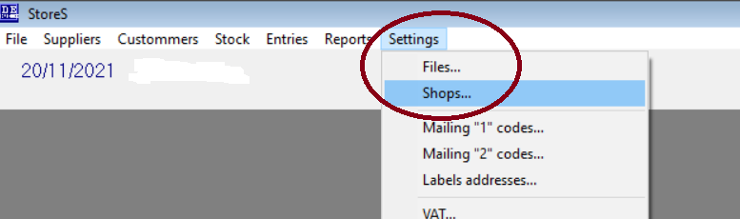

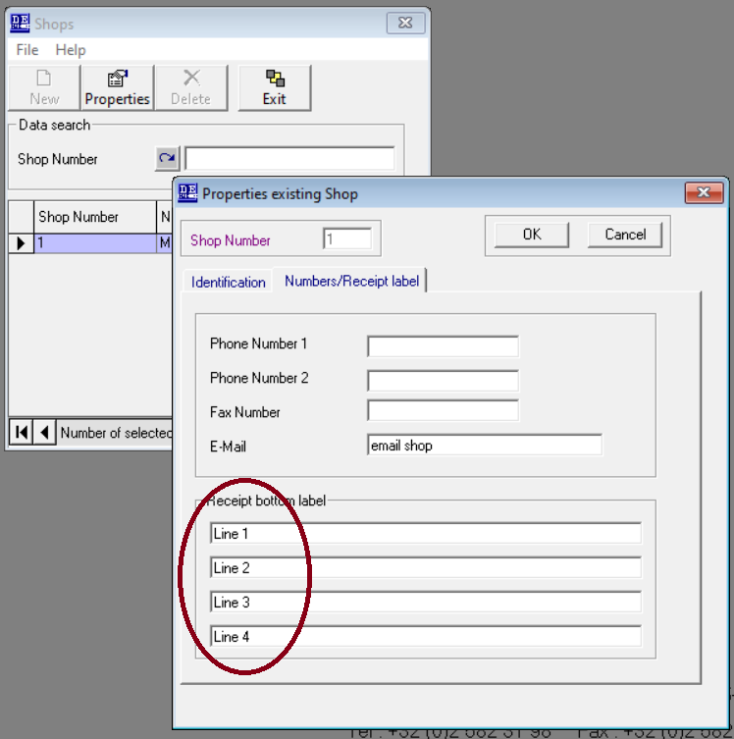
- Barcode

At the bottom of the receipt a barcode will automatically be printed
This barcode represents the ticketnumber.

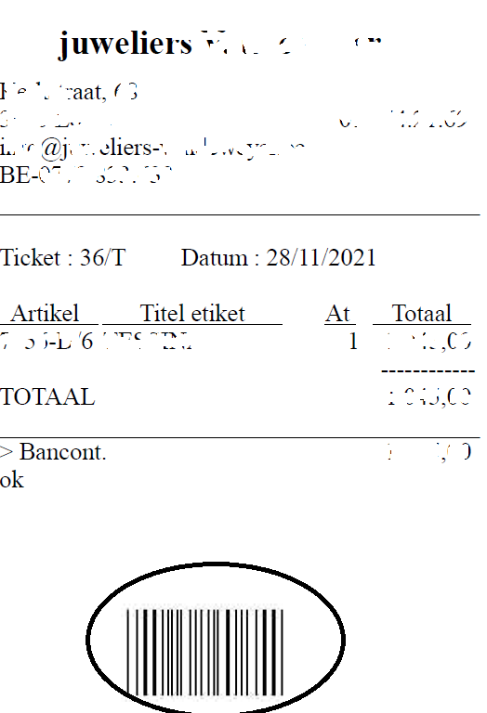

- User ADM or MGR security

- To activate this security, click on the checkbox ADM/MGR
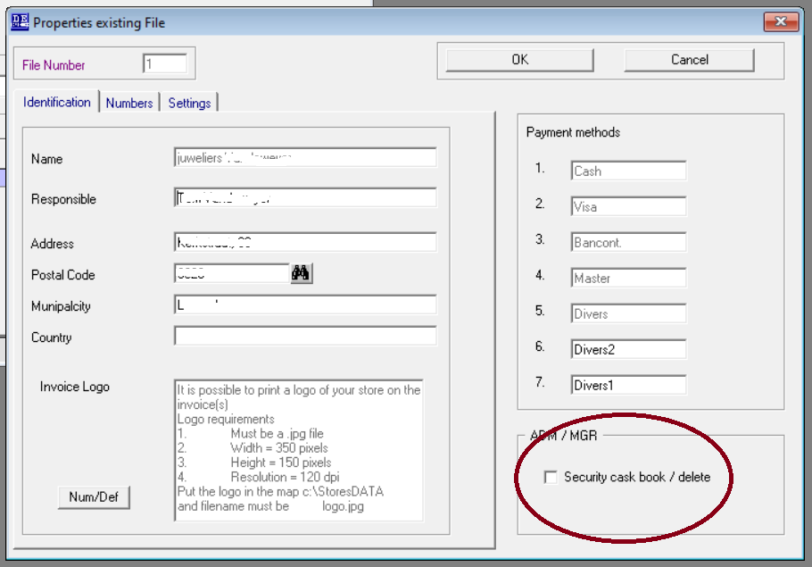

- The reports “sales journal” and “cash book” can only be requested by the user ADM or MGR

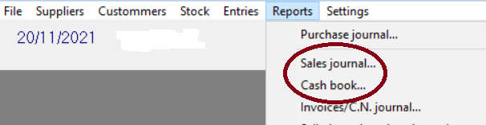

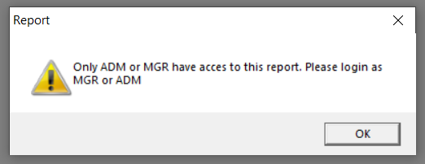

- Only user ADM or MGR can delete an article + its history

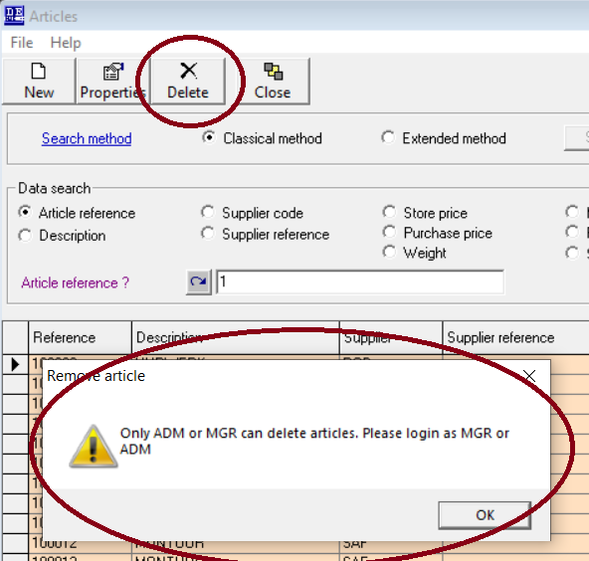

- Only user ADM or MGR can remove lines or documents from a sales (OUTSTOCK) or
Purchase (INSTOCK )

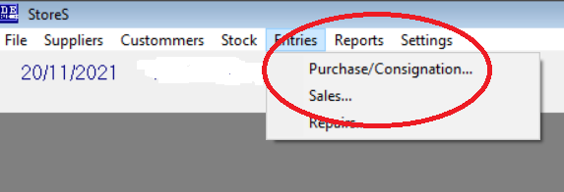

- New payment methods

2 new payment methods have been added.
You can define yourself the name of these payment methods.

Be careful if you change these names during the use of the software
as they are used when selling articles and on reports and refer to a
specific payment method
e.g. if you initiate the first field as “bancontact” and after a year as “cash”
the report that reports on payment method will not be correct as the columns
have another purpose.

How to change the names :

- Select in the menu Settings - Shops

- Fill in the correct names and click on <OK>
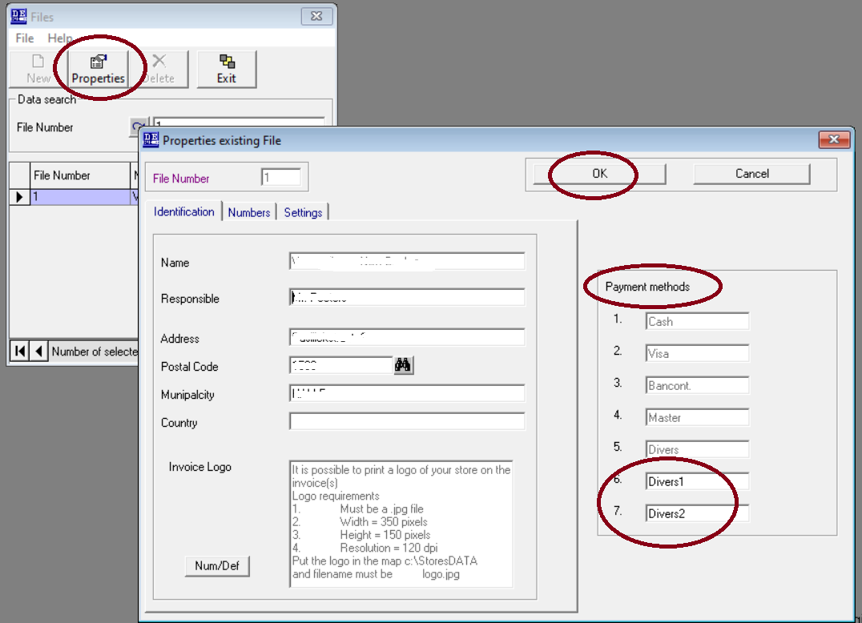
These 2 new payment methods will also be printed on the cash book.

- Display “number of articles in stock” in Articles Overview screen

In the overview of the articles you can activate to display (or not ) the column “number of stock” per article.
- To display “number in stock” of the article on the overview,
check the checkbox “show stock per article”
If you don’t need to display it, uncheck this
- The operation for the calculation of “number in stock” can sometimes be slow on certain old machines or access database.
Therfore you can indicate how many lines need to be displayed and calculated
The lower the number of lines the faster it will be calculated

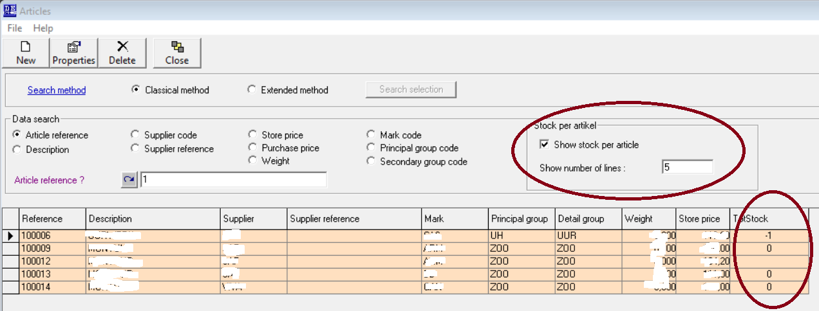

- Make a product certificate

Step 1 : By selecting in het menu <Entries> <Sales> the sales screen will be opened.

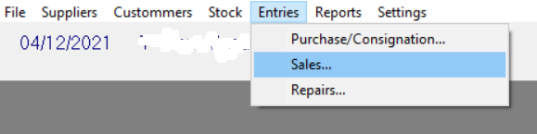

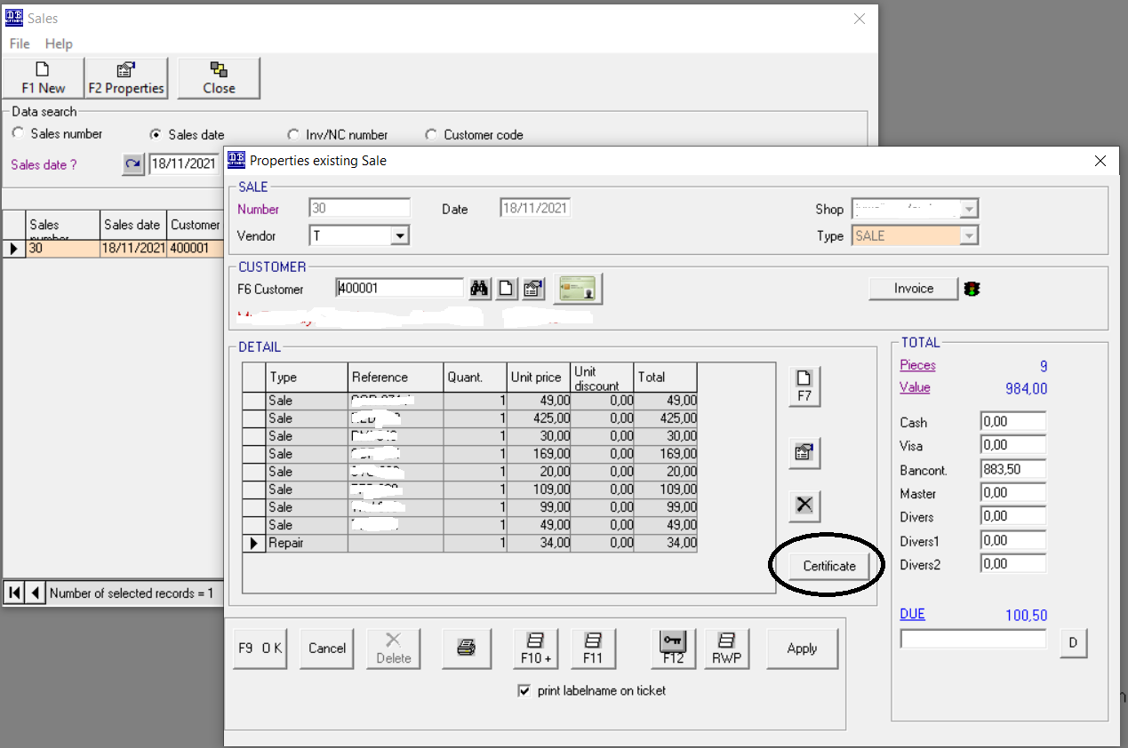

Step 2 : Select a product that has been sold and click on the button <certificate>
Now a new screen will be displayed.
Fill in the details of the product for which the customer needs a certificate.
By default the name and address of the shop will be printed on the certificate.
Or you can define to print an image with the logo ans details of the shop.
This logo should be
    - stored as "c:\StoresData\Certificate.jpg"
    - have a max width of 180 pixels and a height of 250 pixels
See screen below.
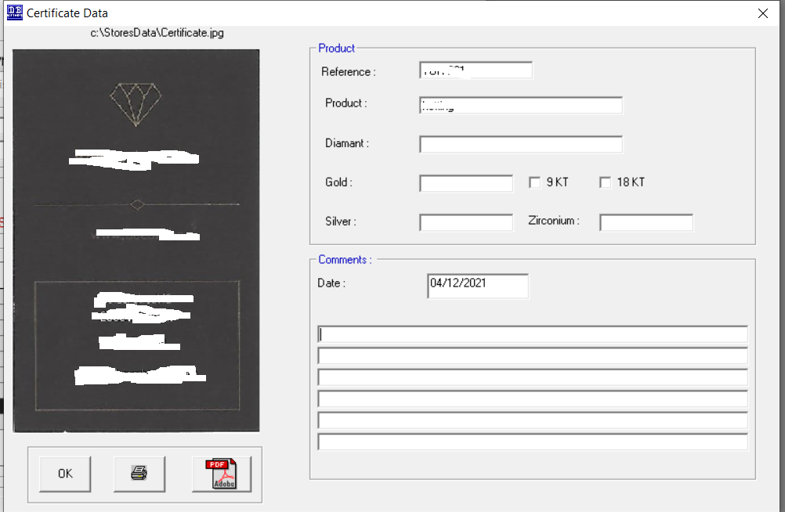

Step 3 : When de fields have been filled in you can choose to Print it or to make a PDF file.

STORES 2021

- Make yearly inventory
- Attach article images
- Configure Own numbering
- Barcodes
- Adjust the stock manually
- Register in Sales : Money take up
- Login screen
- Print inventory with purchase and/or selling price
- VAT ( BTW – TVA ) management
- Gift voucher(s) and VAT : create a gift voucher
- Gift voucher(s) and VAT : pay with a gift voucher
- Email adressess and customers / suppliers
- Chosing another shop in Stores

- (Yearly) Inventory : To keep your stock up to date

Step 1 : In the Main menu choose

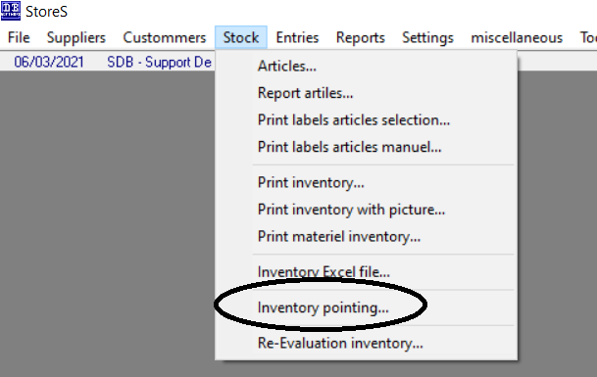

Step 2 : Create a new inventory item
Or update an existing one

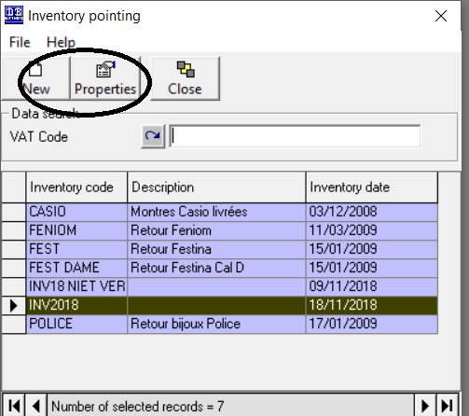

Tip : Code or description the inventory will be in most cases the name of the yearly inventory.

Step 3 : Make inventory and update stock

- Fill i or Select the inventory shop info. ( in case of multiple shops )
Also important is the inventoy date, only stock movements before or on that date will be taken into account
All stock movements after that date will remain unchanged and part of the stock.
- Point all articles 1 by 1
- Select or define the articles you want to be updated
<FROM BEGIN> to <TO END> will automatically select all articles
- You can print some reports to verify the pointed articles and the actual stock before starting the final update process
- This will start the final update process :
  - All pointed article and within the selection of number 3 will be updated with the pointed quantity
  - All other articles, not pointed, will be reset to zero (0)
.
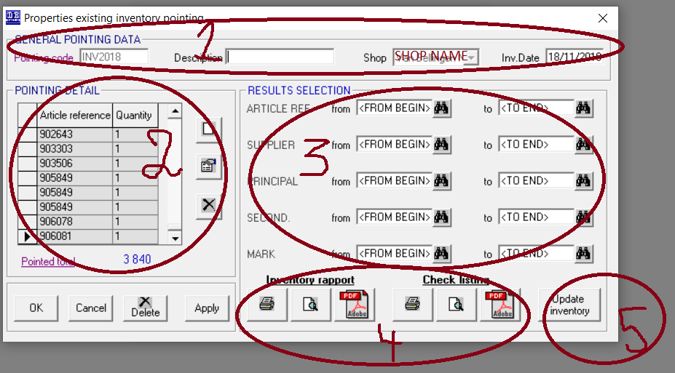

- Attach article images

Step 1 : Define in which map or folder the images will be located.

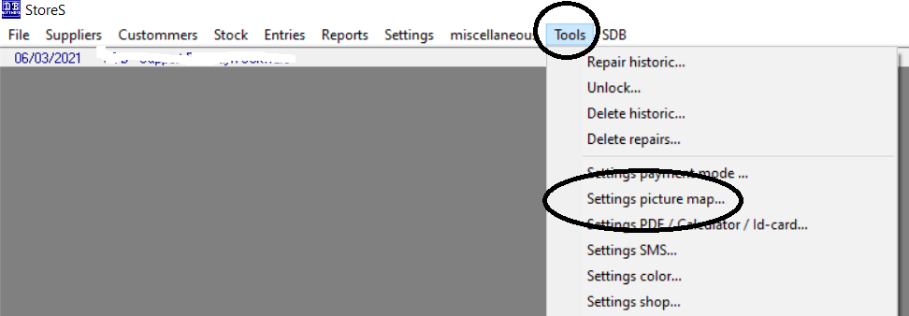

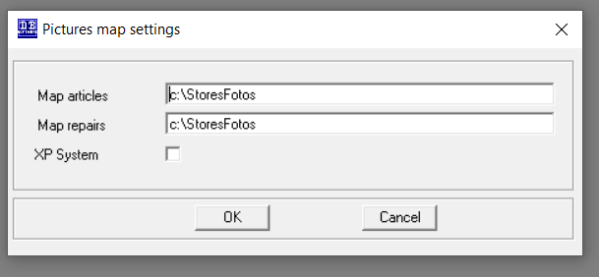

Step 2 : Make or save the article images in the folder.

1. The name of the file must be <reference article>.bmp or .gif or .jpg
e.g. 12000016.jpg
Save the images in a high resolution or in a resolution that fits best your
needs.
The higher the resolution the better the image will be presented but the larger
the file be will.
Image format must be BMP or GIF or JPG

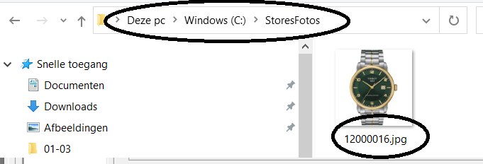

2. This button will visualise the image on the screen.

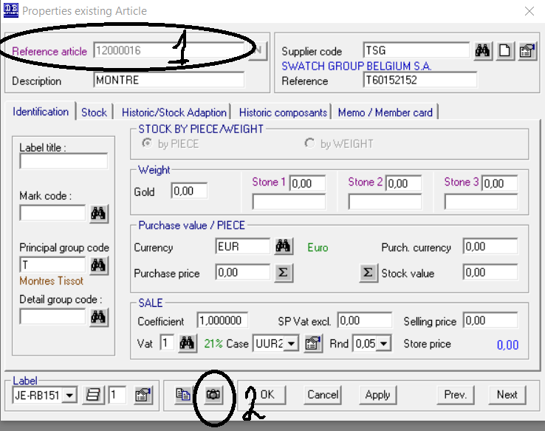

- Configure Own numbering

Step 1 : In the main manu choose Settings – Files or Dossiers

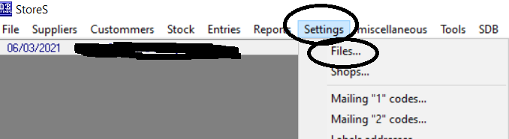

Step 2 : Open the form with the numbers you want to configure
- Select the file or dossier
- Click on properties
- A details window will popup
- with a button “Num/sta”
- Klik on it and here you can configure some own numbering settings.

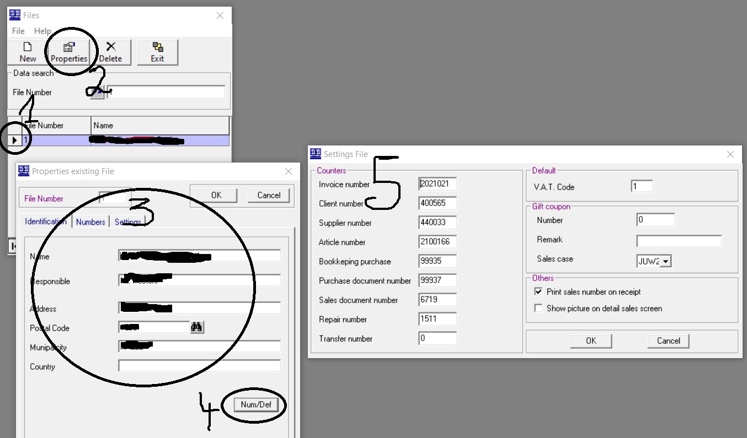

- Barcodes

Stores has a built-in system for barcodes. These barcodes are based on the article or product reference.
The product reference will be encoded into a barcode and can be printed on e.g. a labelprinter.

These labels can be attachted to the articles or products and can be scanned in the sales screen.
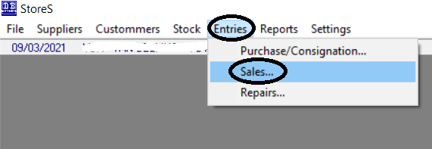

Step 1 : Sales screen
Step 2 : New sales item
Step 3 : Select customer - not yet with a barcode, but can be implemented to scan a customer’s barcode
Step 4 : Select to sell of sold products
Step 5 : Fill in the article of product code or scan the article’s or product’s barcode from a label or page
- To scan a barcode in Stores you need a simple barcode handscanner

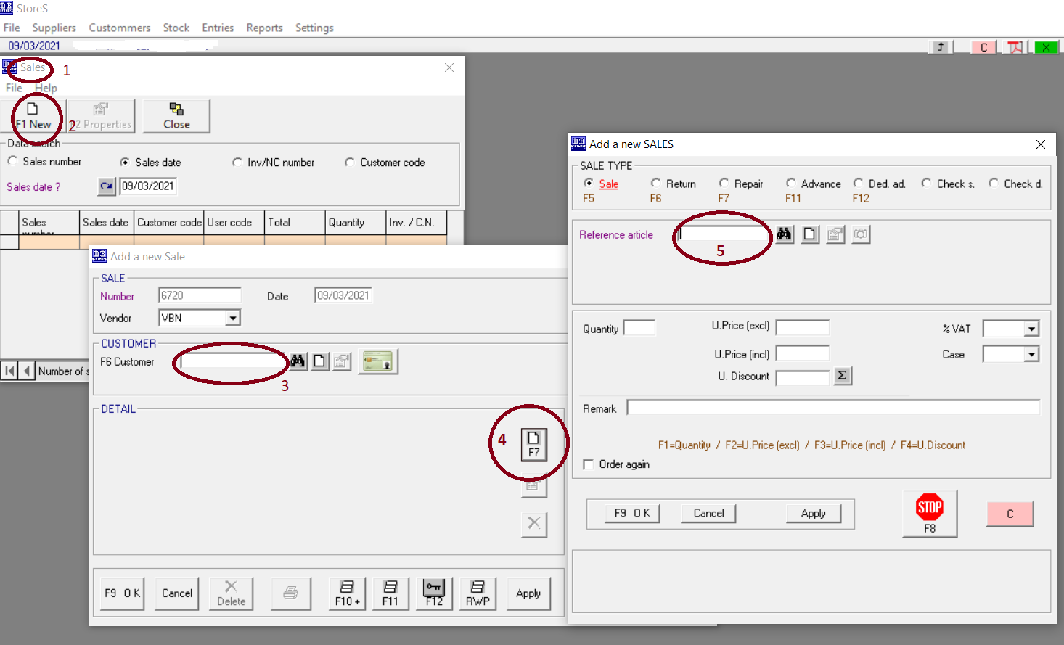

- Adjust the stock manually

The stock is automatically updated when
- A product is being entered in the system ( buy ) : stock +
- A products has been sold ( sell ) : stock -

The stock can also be modified manually, doing :

Step 1: Select in the menu Stock – Articles

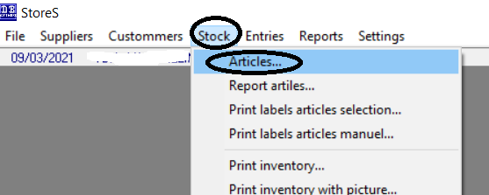

Step 2 : Select a product/article

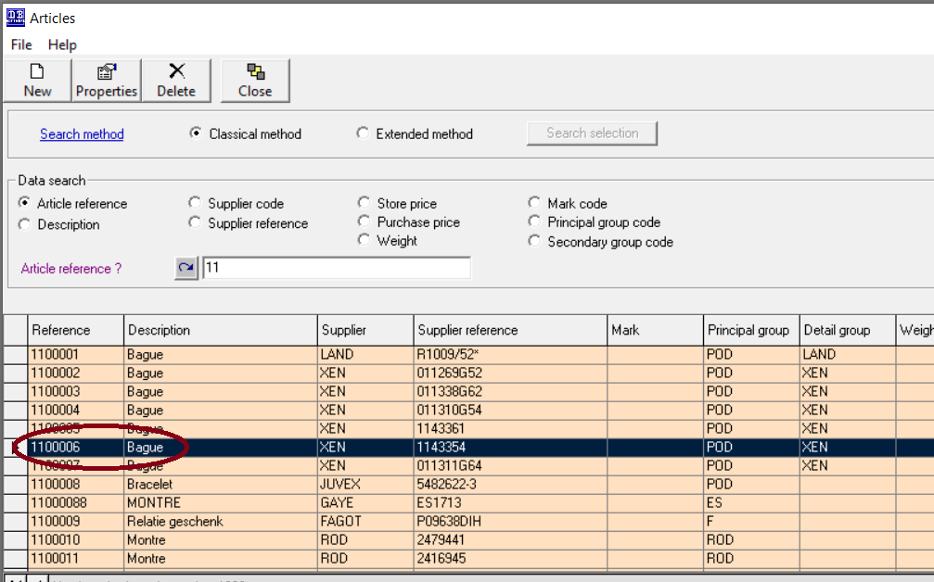

Step 3 : in the properties window of the article select the page “Historic/Stock adaptation”

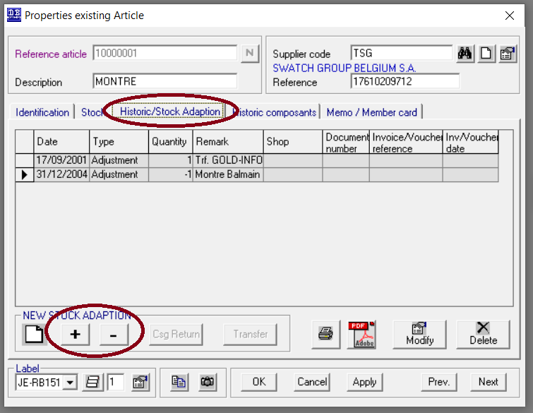

Step 4 : Select plus (+) to increase the stock
Select minus (-) to decrease the stock
Add the correct quantity next to the shopname and enter a remark for the adjustment
Click on OK to save.

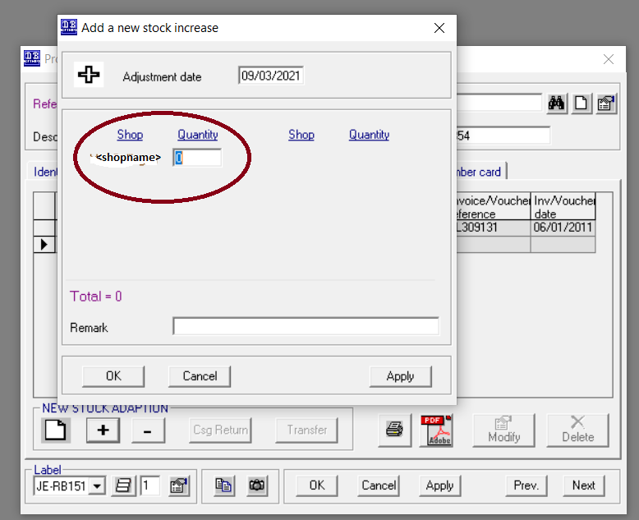

- Register in Sales : Money take up

In the module sales it is possible to register money take up ( cash in and out the cashdrawer ).

Open the “sales window”.

Step 1 : Create a new entry for sales
Step 2 : Select the correct shop ( if you have more shops )
Select “MONEY TAKE UP”
Step 3 : Fill in the amount of cash
Step 4 : Fill in the description
Step 5 : Click on OK to save.

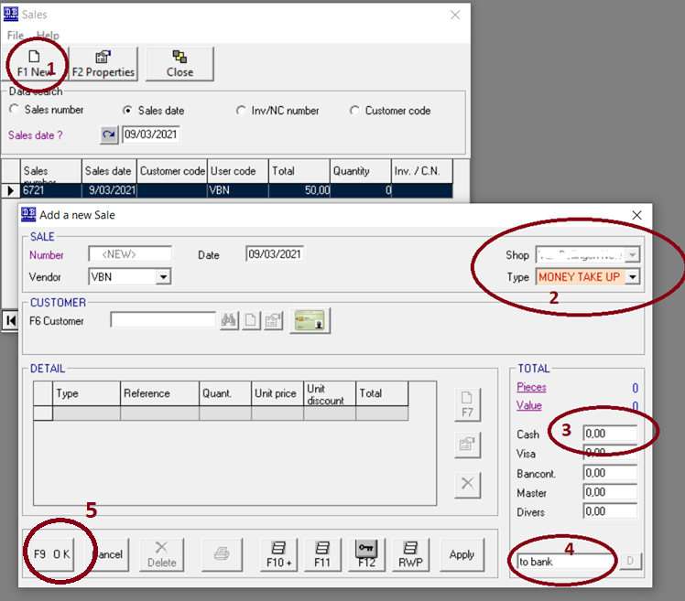

This activity will also become visible in the (Daily) Sales Report.

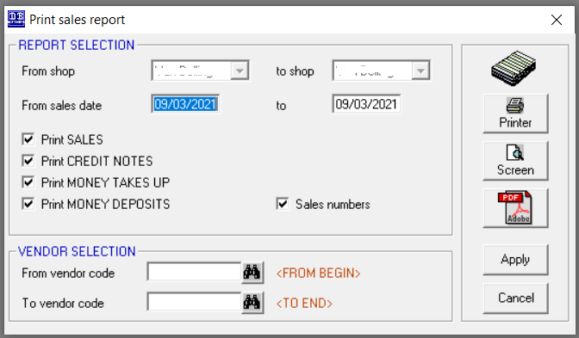

- Login screen

Step 1 : Choose the right user
Step 2 : Fill in the password
Step 3 : Click on OK button or ENTER key to continue

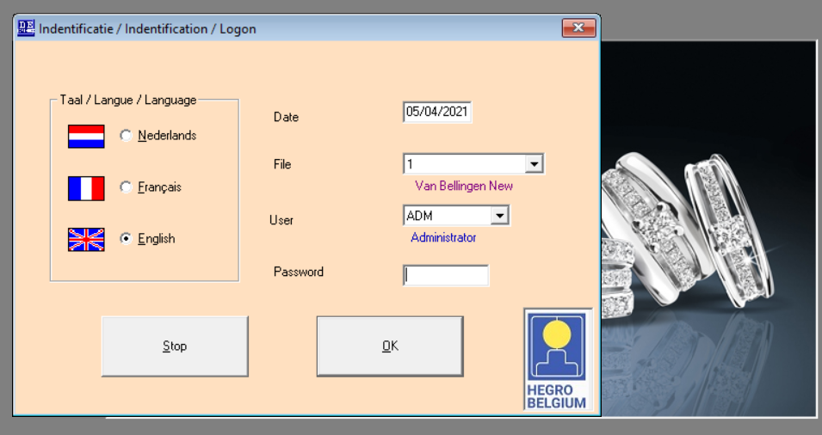

- Print inventory with purchase and/or selling price

If you need the purchase price and selling price on your inventory report do following steps :

Step 1 : Open inventory report
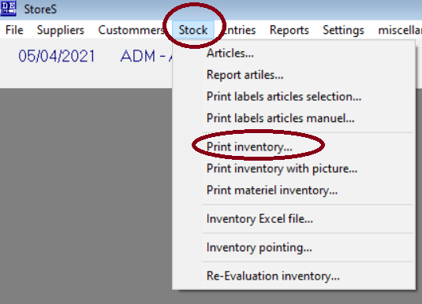

Step 2 :
- Make your selection
- By default the purhasing pice is printed on the report
- For having the selling price on the report, check the option

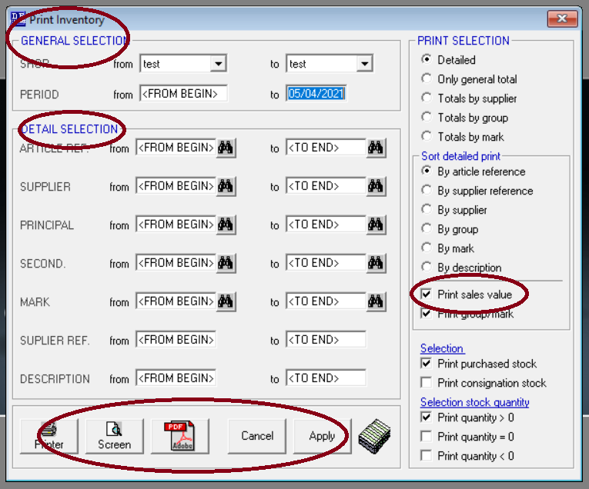

- VAT ( BTW – TVA ) management

You can add, change, remove VAT % in the VAT Management

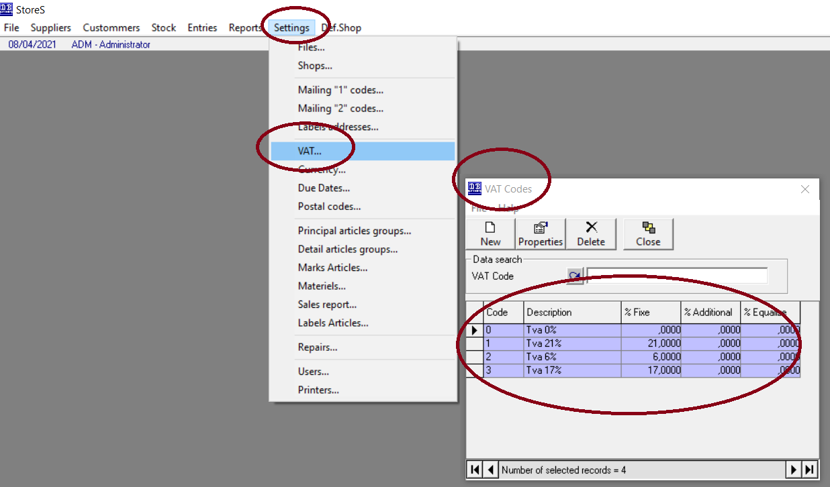

- Gift voucher(s) and VAT : create a gift voucher

The amount on a Gift voucher includes the VAT.
If you create a gift voucher of €121 and the customer buys a product that costs €121, this means that the price = 100 + 21% VAT

To create a gift voucher
- goto Sales
- Add a new sale

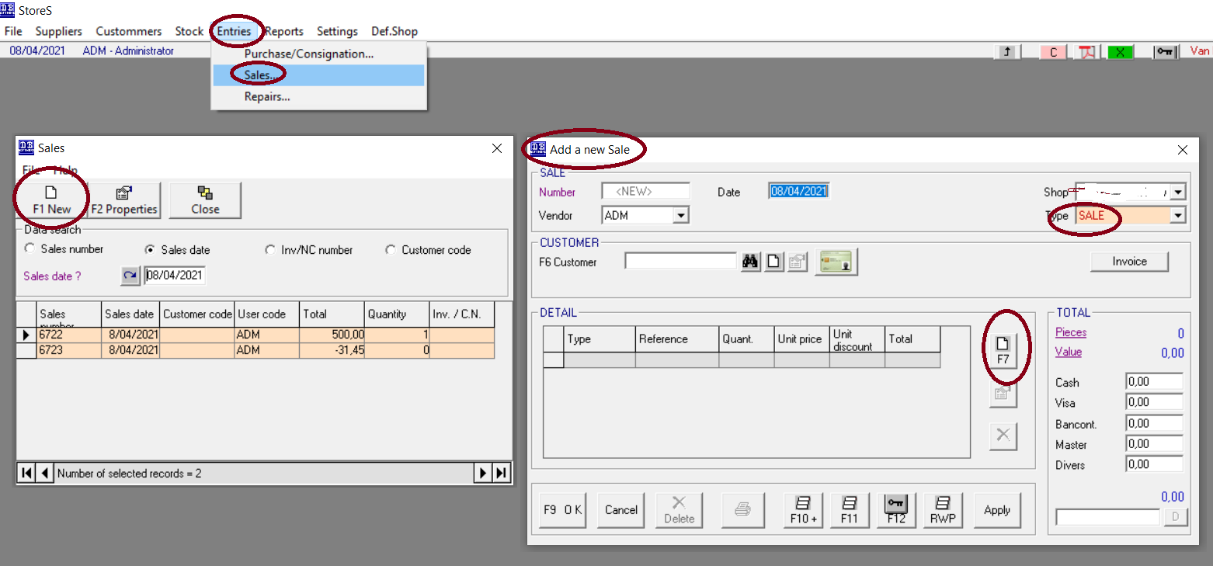

- Fill in the detais :
  - Check the second last radio button ( Check s. )
  - Fill in the gift voucher unique number
  - Fill in the amount of the gift
  - Select the gift % VAT ( 0% tot 21 % )
  - The system will automatically recalculate the amount and the %VAT

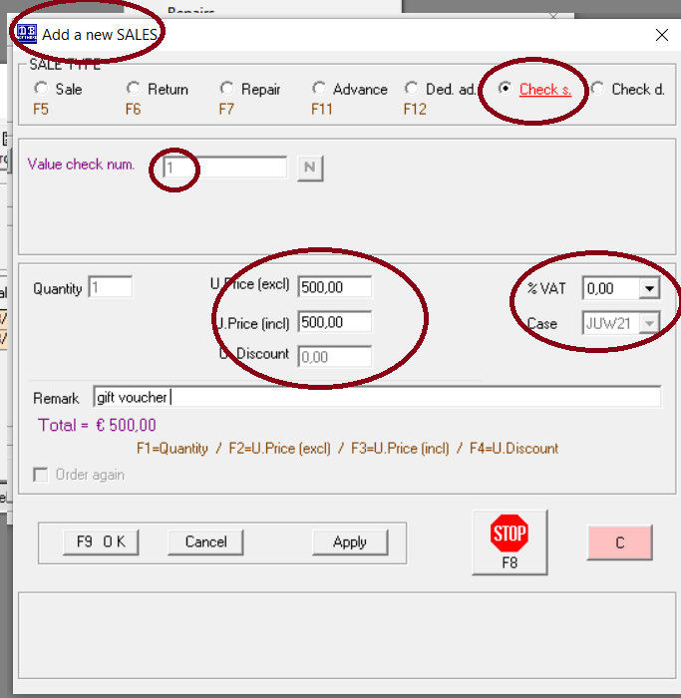

- Click on F9 OK to save
- The gift voucher is ready to use

- Gift voucher(s) and VAT : pay with a gift voucher
The customer can pay the product with a gift voucher.

To register a payment with a gift voucher do following
- goto Sales
- Add a new sale

- Fill in the detais :
  - Check the last radio button ( Check d. )
  - Fill in the gift voucher unique number
  - The system will automatically get the data for this voucher

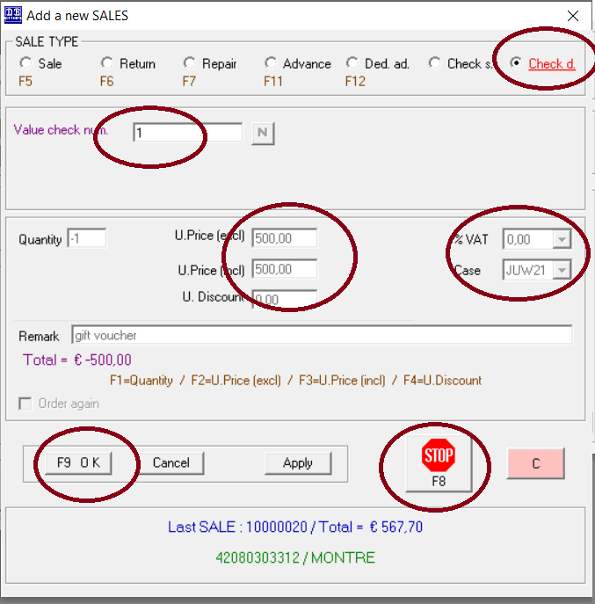
- Press F9 to save
- Press F8 to return tot he previous screen
- The remaining amount to pay is recalculated
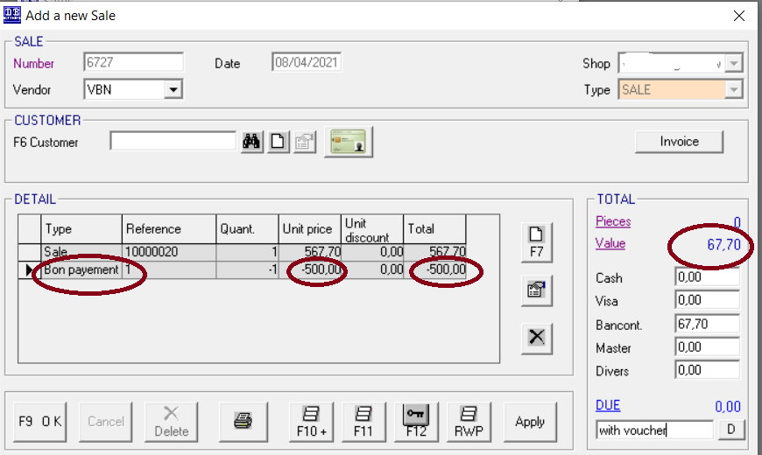

- Press F9 to save, F10 to print

12 Email addresses and customers/suppliers
You can use email adressess to communicate with customer and suplliers.
Emails scan be sent from within the software Stores using the button “Email”.
These emails will be sent using outlook application.

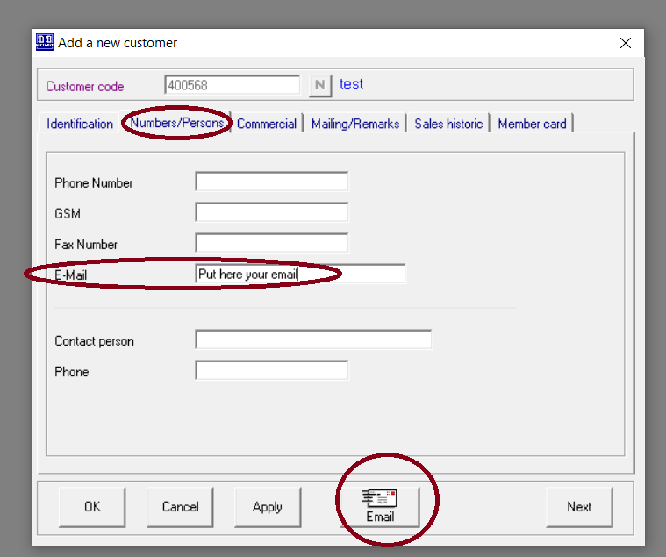

13 Chosing another shop in Stores
Customer who are using Stores with multiple shops van easily choose the shop by clicking
- In the top menu “Def.Shop”
- And choose another shop on the right. A popup will be shown to select another shop

